Standardformulär för sammanlänkade researrangemang

Använd texten i de blå rutorna till er webbplats. Fyll i det som saknas enligt instruktionen på vår webbplats. Ruta 1 ska alltid synas tydligt för konsumenten, ruta 2 ska man länka till från ruta 1.
Se exempel.

Exempel ruta 1
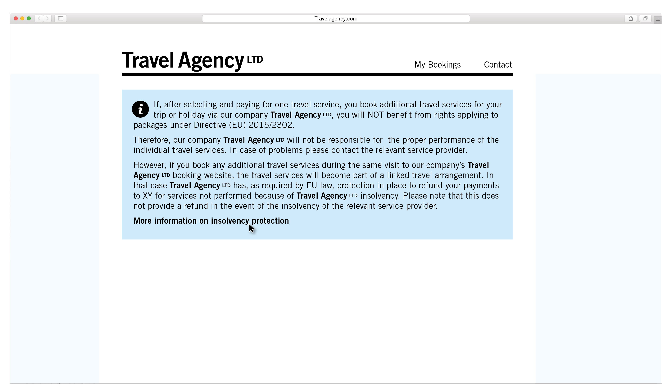

Exempel ruta 2
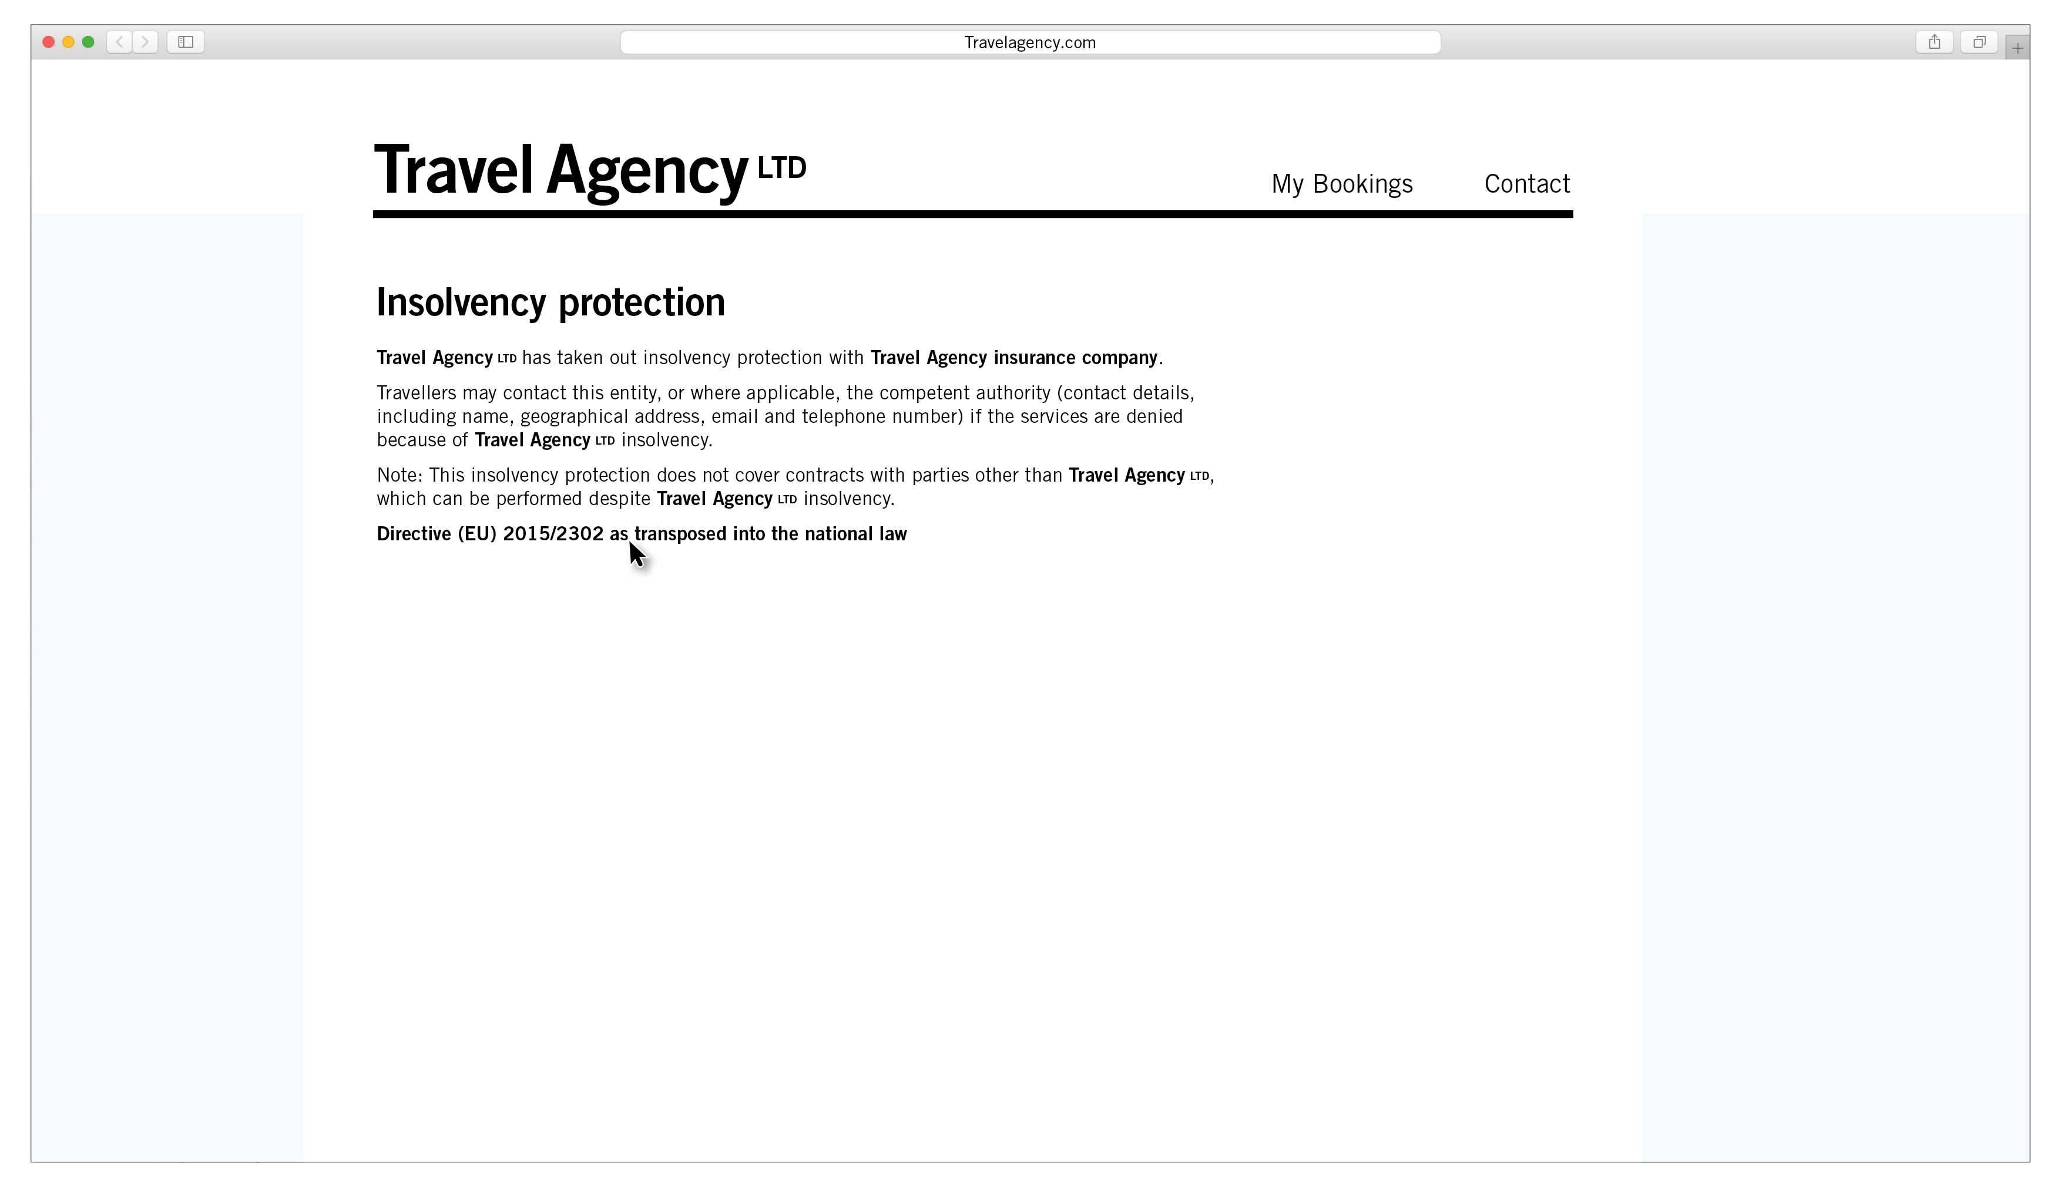

Text till ruta 1

If, after selecting and paying for one travel service, you book additional travel services for your trip or holiday via our company "XY", you will NOT benefit from rights applying to packages under Directive (EU) 2015/2302.

Therefore, our company "XY" will not be responsible for the proper performance of the individual travel services. In case of problems please contact the relevant service provider.

However, if you book any additional travel services during the same visit to our company's "XY"'s booking website, the travel services will become part of a linked travel arrangement. In that case "XY" has, as required by EU law, protection in place to refund your payments to "XY" for services not performed because of "XY"'s insolvency. Please note that this does not provide a refund in the event of the insolvency of the relevant service provider.

More information on insolvency protection

Text till ruta 2

"XY" has taken out insolvency protection with "YZ (the entity in charge of the insolvency protection, e.g. a guarantee fund or an insurance company)".

Travellers may contact this entity, or where applicable, the competent authority Kammarkollegiet, Birger Jarlsgatan 16, 114 34 Stockholm,
08-700 08 00, registratur@kammarkollegiet.se
if the services are denied because of "XY"'s insolvency.

Note: This insolvency protection does not cover contracts with parties other than "XY", which can be performed despite "XY"'s insolvency.

Directive (EU) 2015/2302 as transposed into the national law
https://svenskforfattningssamling.se/doc/20181217.html

